My own kiss file:

.start_kiss

.i 1

.o 1

.p 10

.s 5

.r a

0 a a 0

1 a b 0

0 b a 0

1 b c 1

0 c b 0

1 c a 0

0 d d 0

1 d b 1

0 f a 0

1 f c 1

.end_kiss

My own output kiss file:

.start_kiss

.i 1

.o 1

.p 8

.s 4

.r a

0 a a 0

1 a b 0

0 b a 0

1 b c 1

0 c b 0

1 c a 0

0 d d 0

1 d b 1

.end_kiss

Screenshots of my own input STG:

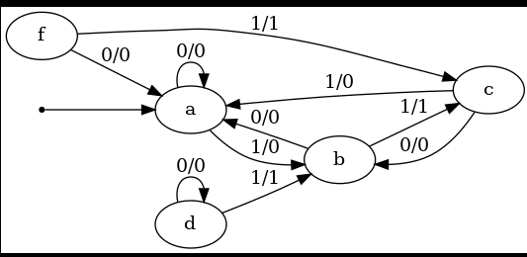

Screenshots of my own output STG:

